# Spring with microservices

## Web services

### What is?

It’s a software system designed to support interoperable machine-to-machine interaction over a network.

In 3 keys:

* Designed for machine-to-machine (or application to application) interaction.
* Should be interoperable – Not platform dependent.
* Should allow communication over a network

### SOAP

* It means Simple Object Access Protocol.
* Uses XML as exchange format.
* It’s composed by the **envelope**, **header** and **body**:
  + **Envelope:** Contains SOAP information
  + **Header:** Contains meta information, like authentication, authorization, signatures, etc.
  + **Body:** Contains the request or response body.

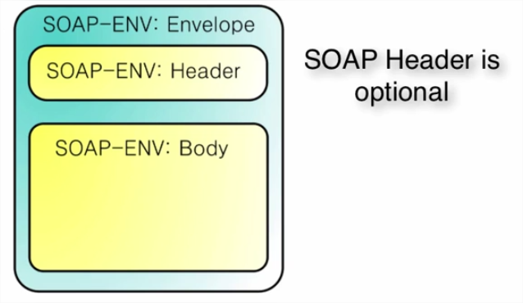

* Uses MQ or HTTP as transport.
* The service definition is WSDL (Web Service Definition Language), where the endpoints and operations are exposed.

### REST

* No restriction on data exchange format. JSON is popular
* Transport only HTTP.
* It has no service definition, it can be WADL, Swagger, etc.

### REST vs SOAP

It’s not an apple to apple comparison. SOAP is a format of a XML and REST is an architectural style.